LAB 2

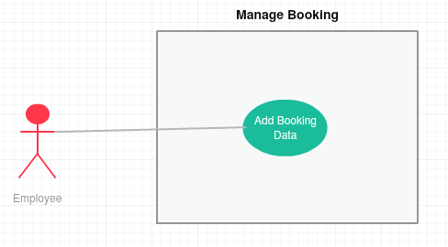

|  |  |
| --- | --- |
| **Use Case ID** | OCRMS-UC-01 |
| **Use Case Name** | Manage Booking |
| **Brief Description** | This use case is used by employee to add booking data |
| **Actor** | Employee |
| **Pre-Conditions** | employee must has login into the system |
| **Basic Flow** | Employee   1. Employee get to view the list of bookings for that day by clicking the “availability”. 2. Employee identify the null booking and booking that over the rental period. 3. Employee add booking data in database |
| **Alternative Flow** | Not applicable |
| **Exception Flow** | Not applicable |
| **Post-Conditions** | Employee successfully booked a car |
| **Rules** | Not applicable |
| **Constraints** | Need to check the internet connection |

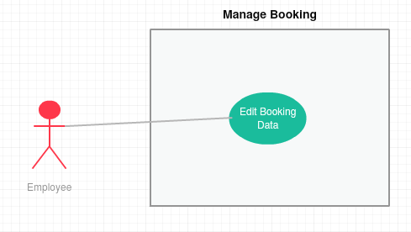

|  |  |
| --- | --- |
| **Use Case ID** | OCRMS-UC-02 |
| **Use Case Name** | Manage Booking |
| **Brief Description** | This use case is used by employee to edit booking data |
| **Actor** | Employee |
| **Pre-Conditions** | employee must has login into the system |
| **Basic Flow** | Employee   1. Employee get to edit the bookings by clicking the “edit” button. 2. Employee edit booking data in database 3. Output save successfully appear |
| **Alternative Flow** | Not applicable |
| **Exception Flow** | Not applicable |
| **Post-Conditions** | Employee successfully edit a booking |
| **Rules** | Not applicable |
| **Constraints** | Need to check the internet connection |

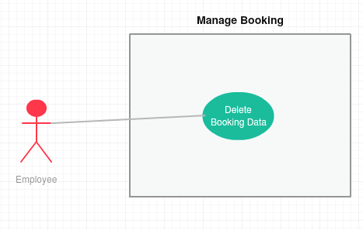

|  |  |
| --- | --- |
| **Use Case ID** | OCRMS-UC-03 |
| **Use Case Name** | Manage Booking |
| **Brief Description** | This use case is used by employee to delete booking data |
| **Actor** | employee |
| **Pre-Conditions** | employee must has login into the system |
| **Basic Flow** | Employee   1. Employee get to delete the bookings by clicking the “delete” button. 2. Employee delete booking data in database 3. Output save successfully appear |
| **Alternative Flow** | Not applicable |
| **Exception Flow** | Not applicable |
| **Post-Conditions** | employee successfully delete a booking |
| **Rules** | Not applicable |
| **Constraints** | Need to check the internet connection |

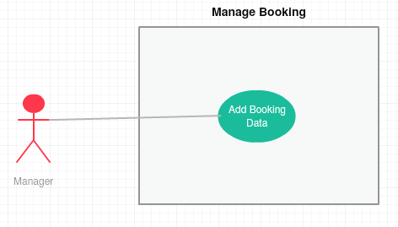

|  |  |
| --- | --- |
| **Use Case ID** | OCRMS-UC-04 |
| **Use Case Name** | Manage Booking |
| **Brief Description** | This use case is used by manager to add booking data |
| **Actor** | manager |
| **Pre-Conditions** | manager must has login into the system |
| **Basic Flow** | Manager   1. manager get to view the list of bookings for that day by clicking the “availability”. 2. manager identify the null booking and booking that over the rental period. 3. manager add booking data in database |
| **Alternative Flow** | Not applicable |
| **Exception Flow** | Not applicable |
| **Post-Conditions** | manager successfully booked a car |
| **Rules** | Not applicable |
| **Constraints** | Need to check the internet connection |

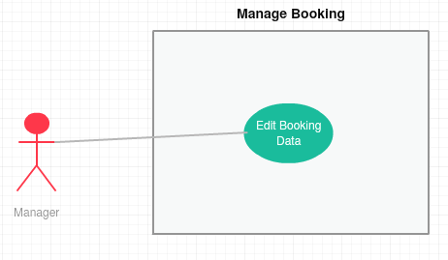

|  |  |
| --- | --- |
| **Use Case ID** | OCRMS-UC-05 |
| **Use Case Name** | Manage Booking |
| **Brief Description** | This use case is used by manager to edit booking data |
| **Actor** | manager |
| **Pre-Conditions** | manager must has login into the system |
| **Basic Flow** | Manager   1. manager get to edit the bookings by clicking the “edit” button. 2. manager edit booking data in database 3. Output save successfully appear |
| **Alternative Flow** | Not applicable |
| **Exception Flow** | Not applicable |
| **Post-Conditions** | manager successfully edit a booking |
| **Rules** | Not applicable |
| **Constraints** | Need to check the internet connection |

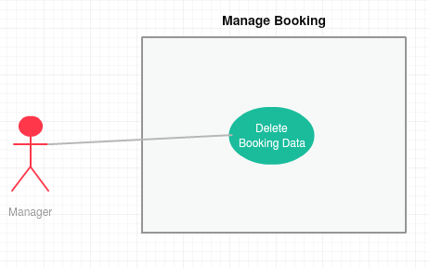

|  |  |
| --- | --- |
| **Use Case ID** | OCRMS-UC-06 |
| **Use Case Name** | Manage Booking |
| **Brief Description** | This use case is used by manager to delete booking data |
| **Actor** | manager |
| **Pre-Conditions** | manager must has login into the system |
| **Basic Flow** | Manager   1. manager get to delete the bookings by clicking the “delete” button. 2. manager delete booking data in database 3. Output save successfully appear |
| **Alternative Flow** | Not applicable |
| **Exception Flow** | Not applicable |
| **Post-Conditions** | manager successfully delete a booking |
| **Rules** | Not applicable |
| **Constraints** | Need to check the internet connection |